Angular
https://youtu.be/NvJcSWL-jzE?si=umSTSRK9o16TOKA7
- Angular is an open-source front-end web application framework developed by Google. It's used for building single-page client applications using HTML, CSS, and JavaScript/TypeScript.
- Architecture:
  - Angular follows the MVC (Model-View-Controller) architecture.
  - Components are the basic building blocks of an Angular application.
  - Modules help organize the application into cohesive blocks of functionality.
  - Services are singletons that provide functionality that can be shared across components.
- Components:
  - Components are the main building blocks in Angular applications.
  - Each component consists of a template, class, and metadata.
  - Templates are written in HTML with Angular directives and binding syntax.
  - Classes contain properties and methods that define the component's behavior.
  - Metadata is defined using decorators like @Component.
- Data Binding: Angular supports different types of data binding:
  - Interpolation: {{ expression }}
  - Property binding: [property]="expression"
  - Event binding: (event)="handler"
  - Two-way binding: [(ngModel)]="property"
- Directives:
  - Directives are markers on a DOM element that tell Angular to do something with that element.
  - Structural directives: *ngIf, *ngFor, *ngSwitch
  - Attribute directives: ngClass, ngStyle, ngModel
- Services:
  - Services are reusable pieces of code that can be injected into components or other services.
  - They are commonly used for fetching data from APIs, sharing data between components, or performing common tasks.
- Dependency Injection: Angular uses dependency injection to provide instances of services to components and other services.
  - Dependencies are provided at the component level or in the module's providers array.
- Routing: Angular's Router enables navigation between different components.
  - Routes are defined in the RouterModule and configured using Route objects.
  - Route parameters can be used to pass data between components.
- Modules: Angular applications are modularized into NgModules.
  - NgModules are containers for a cohesive block of code dedicated to an application domain, workflow, or closely related set of capabilities.
  - Every Angular app has at least one module, the root module, conventionally named AppModule.
- Forms: Angular provides two approaches for working with forms:
  - Template-driven forms: Forms are created and manipulated in the component's template.
  - Reactive forms: Forms are built programmatically in the component class using FormBuilder and FormControl.
- Angular Universal (Server-side Rendering): Angular Universal enables server-side rendering of Angular applications.

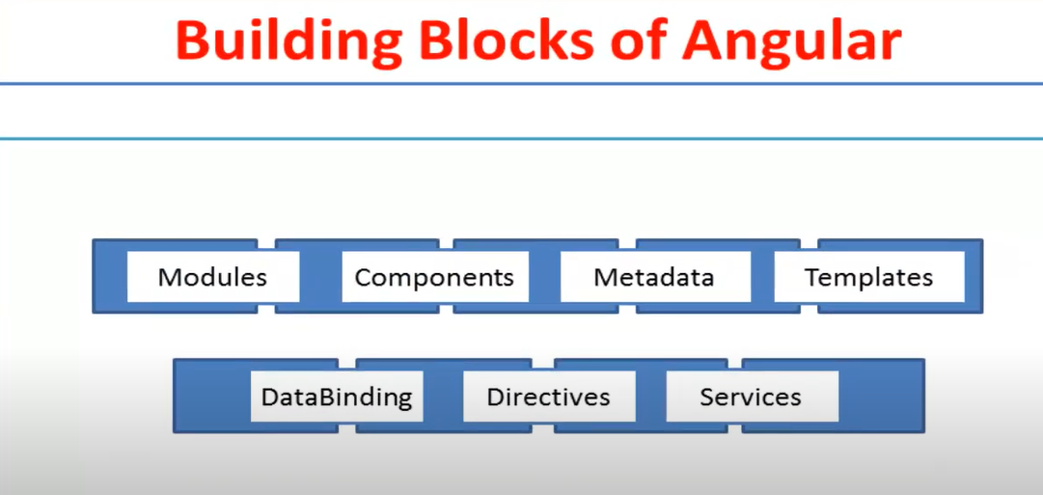
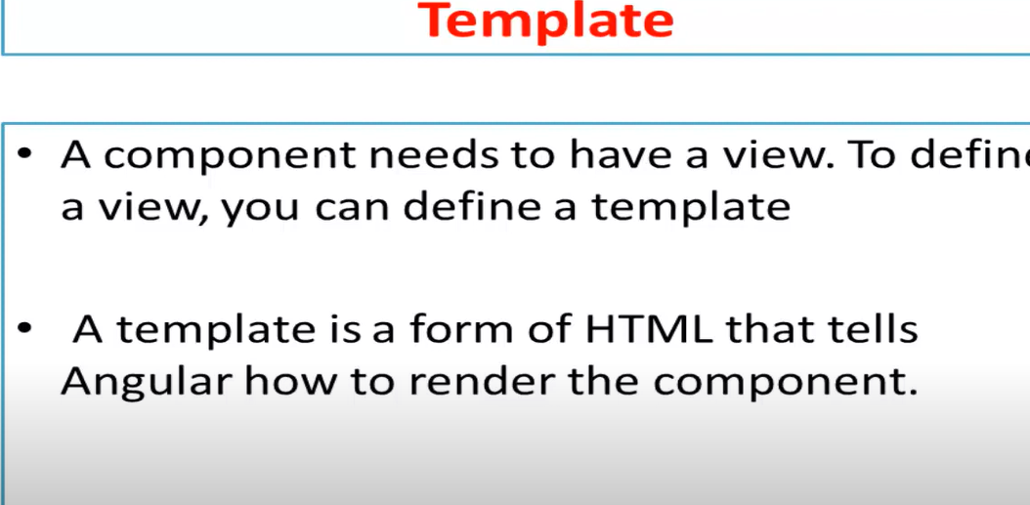
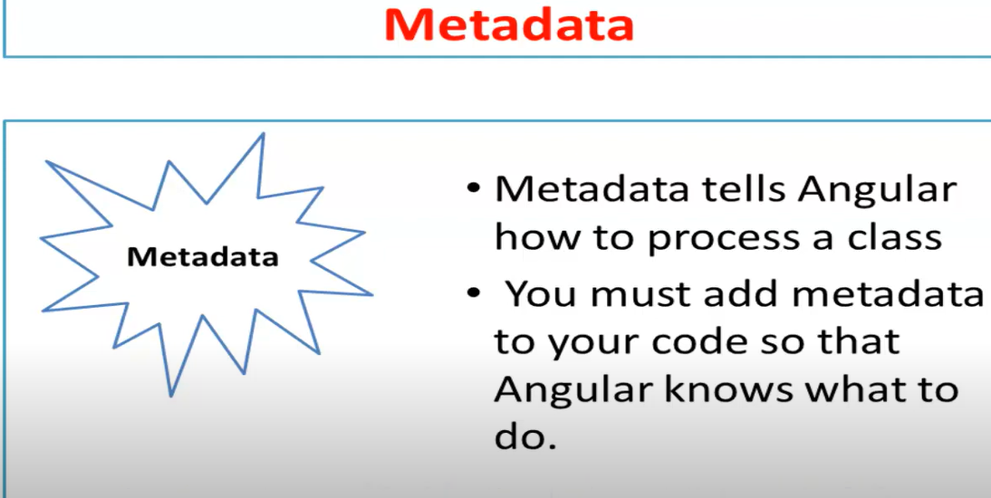
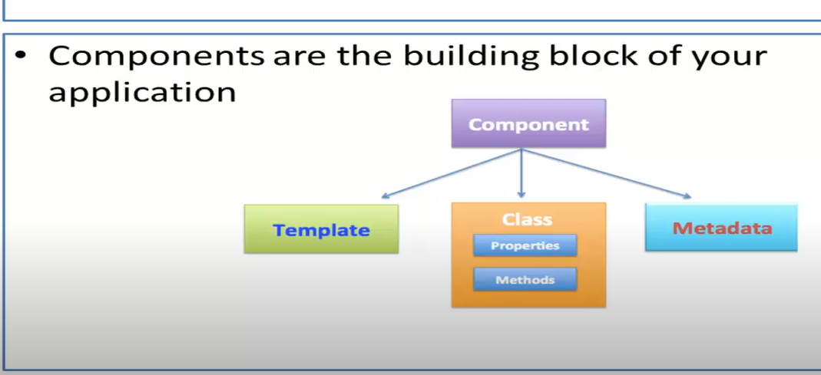
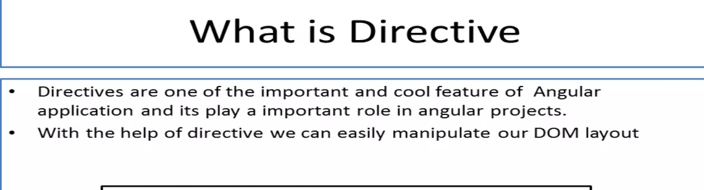
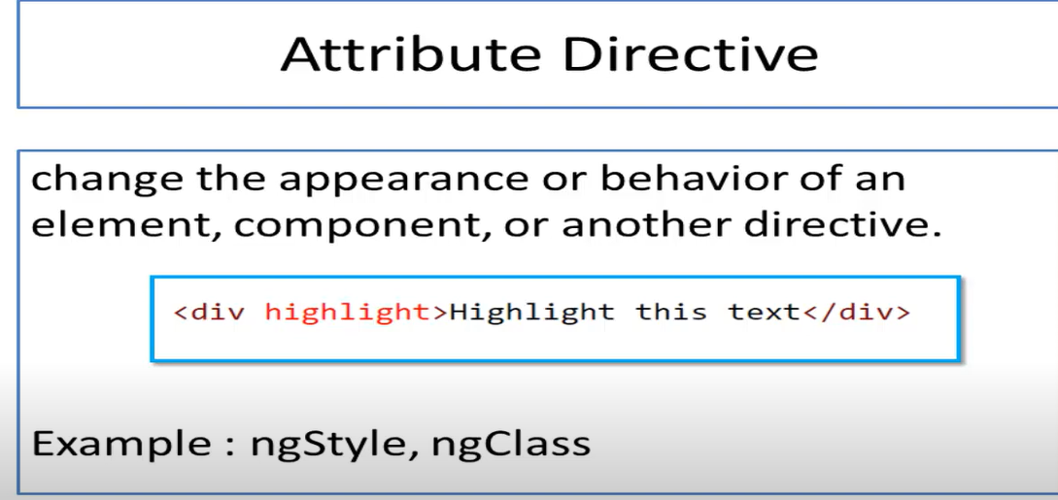
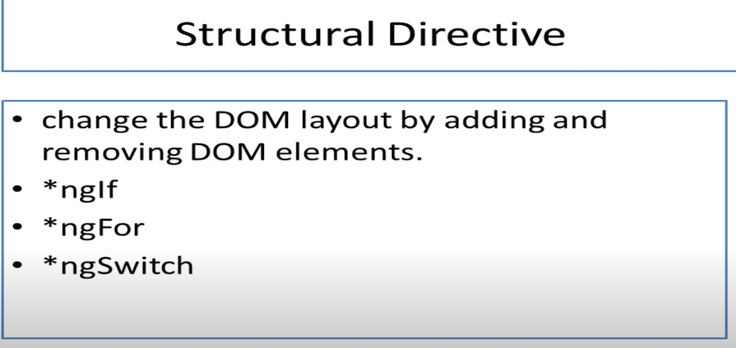

Benefits

- Modularity and Reusability: Angular promotes modularity by breaking down applications into smaller, reusable components. This modular approach makes it easier to maintain and scale applications, as individual components can be developed, tested, and reused independently.
- Two-Way Data Binding: Angular provides two-way data binding, which allows automatic synchronization of data between the model (in the component) and the view (HTML template). This simplifies the process of building dynamic and responsive user interfaces.
- Dependency Injection (DI): Angular's built-in dependency injection system makes it easy to manage dependencies and promote loose coupling between components. This helps improve code maintainability, testability, and scalability.
- Built-in Directives and Pipes: Angular comes with a rich set of built-in directives (e.g., ngIf, ngFor, ngSwitch) and pipes (e.g., date, currency, uppercase) that simplify common tasks in web development, such as data manipulation, conditional rendering, and DOM manipulation.
- Cross-Platform Development: With Angular, you can build web applications that run seamlessly across different platforms, including desktop, mobile, and web. Angular's platform-agnostic nature allows developers to use the same codebase to target multiple platforms, thanks to tools like Angular Universal for server-side rendering and Ionic for mobile app development.
- TypeScript: Angular is built with TypeScript, a superset of JavaScript that adds static typing, classes, and interfaces to the language. TypeScript enhances developer productivity by providing features like type checking, code navigation, and refactoring, which lead to fewer runtime errors and better code maintainability.
- Strong Community and Ecosystem: Angular has a large and active community of developers, contributors, and enthusiasts who provide support, share knowledge, and contribute to the ecosystem with libraries, tools, and resources. The extensive ecosystem includes Angular Material for UI components, Angular CLI for project scaffolding, and RxJS for reactive programming.
- Official Documentation and Support: Angular has comprehensive official documentation, tutorials, and guides that cover all aspects of the framework, making it easy for developers to learn and get started with Angular development. Additionally, Angular offers official support through its team, forums, and GitHub repository.
- Performance Optimization: Angular provides features and tools for optimizing application performance, including Ahead-of-Time (AOT) compilation, lazy loading, code splitting, and tree shaking. These techniques help reduce application bundle size, improve loading times, and enhance overall performance.
- Maintainability and Long-Term Support: Angular follows best practices and design patterns that promote code maintainability, scalability, and longevity. Additionally, Angular offers long-term support (LTS) versions with extended support and updates, ensuring that applications built with Angular remain stable and secure over time.

Forms
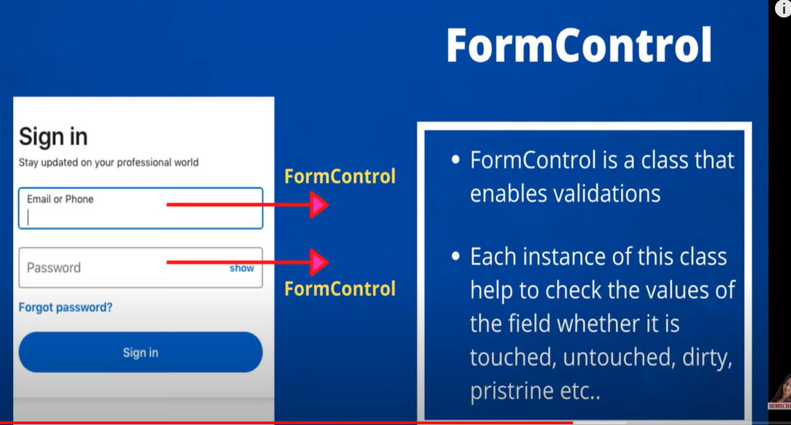
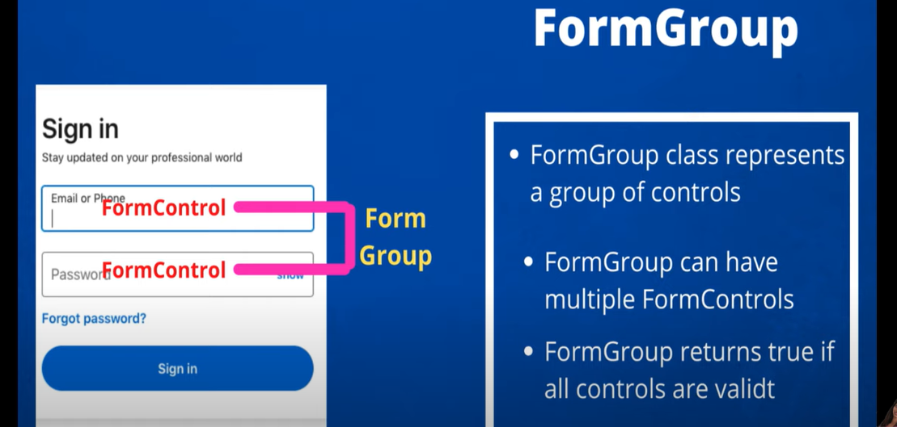
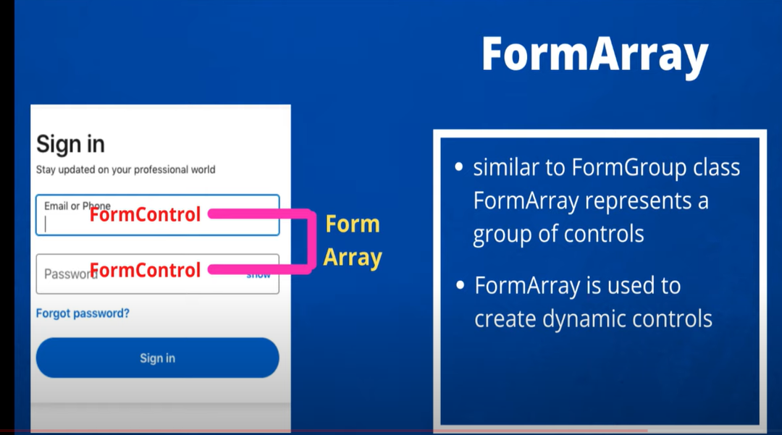
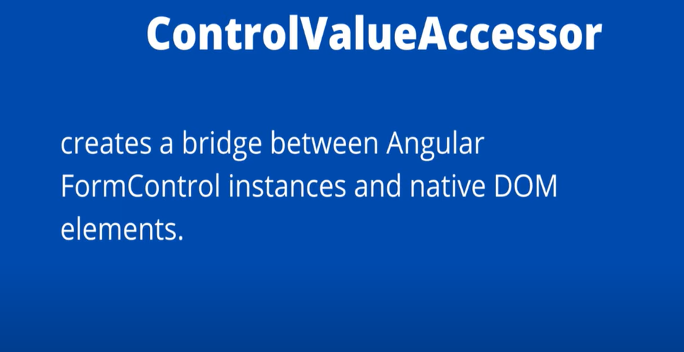
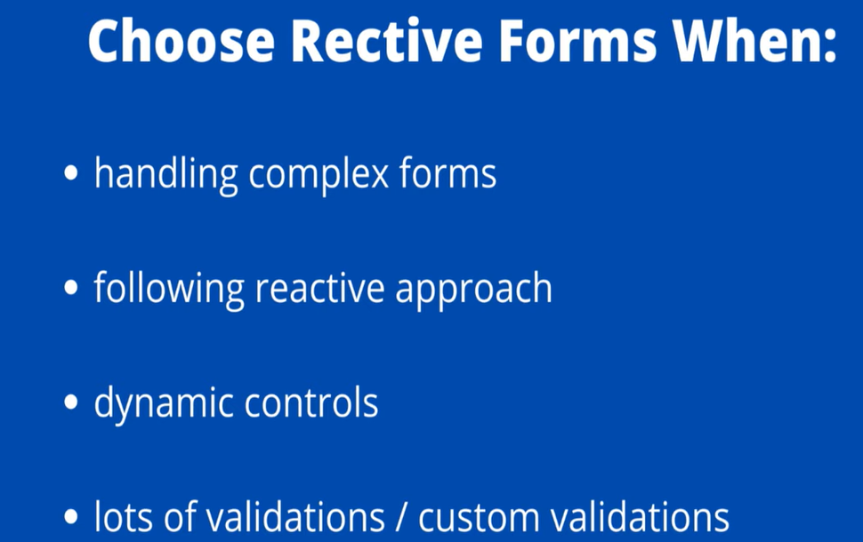
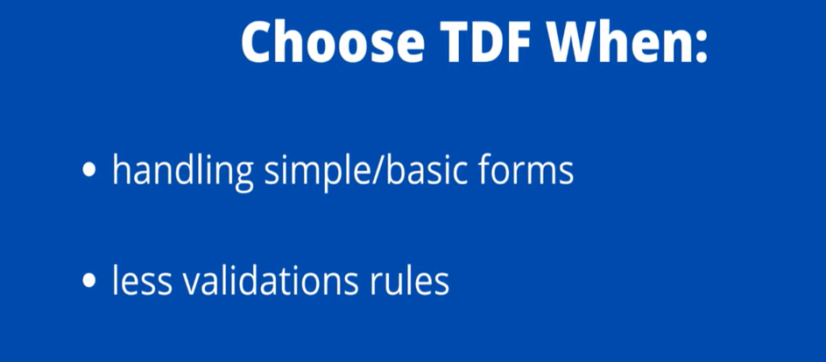

- Template driven form
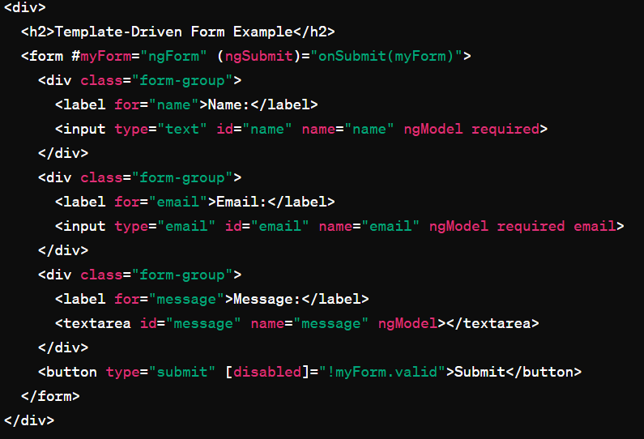
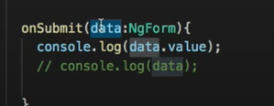
Should import formsmodule where mgModel is there
Name attribute will be the key for ngModel

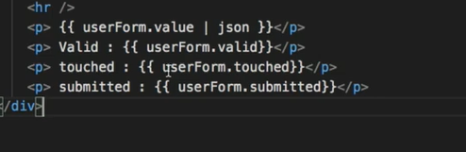
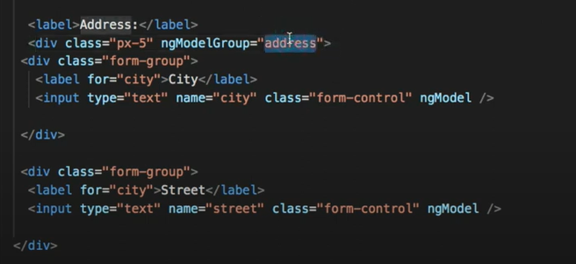
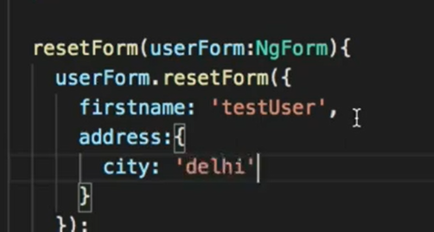

- Reactive Form
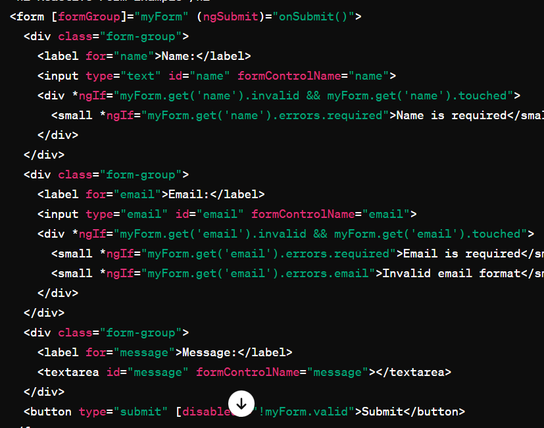
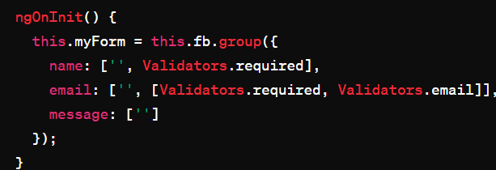

Dynamically updating form control
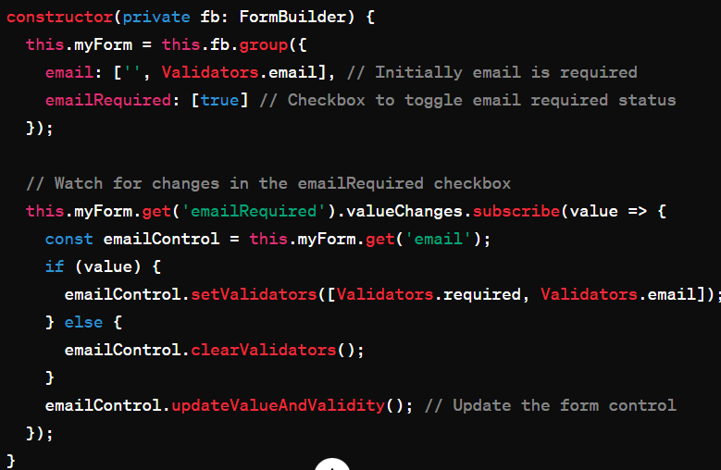

Architecture
MVC stands for Model-View-Controller, which is a software architectural pattern used in designing and developing applications, especially web applications. The MVC pattern separates an application into three interconnected components: Model, View, and Controller. Each component has distinct responsibilities and interacts with each other in a structured manner.
Here's a breakdown of each component in the MVC pattern:
- Model:
  - The Model represents the application's data and business logic.
  - It encapsulates the data structure, business rules, and logic for manipulating the data.
  - It interacts with the database, APIs, or other data sources to perform CRUD (Create, Read, Update, Delete) operations.
  - The Model notifies the View of any changes in the data.
- View:
  - The View represents the user interface (UI) of the application.
  - It presents the data from the Model to the user in a meaningful way.
  - It is responsible for rendering the UI elements, such as HTML, CSS, and sometimes JavaScript.
  - The View listens for user input and sends it to the Controller for processing.
- Controller:
  - The Controller acts as an intermediary between the Model and the View.
  - It receives user input from the View and processes it.
  - It updates the Model based on user actions or input.
  - It selects the appropriate View to display to the user based on the current state of the application.
  - In web applications, the Controller handles HTTP requests, performs business logic, and returns responses to the client.

Routing
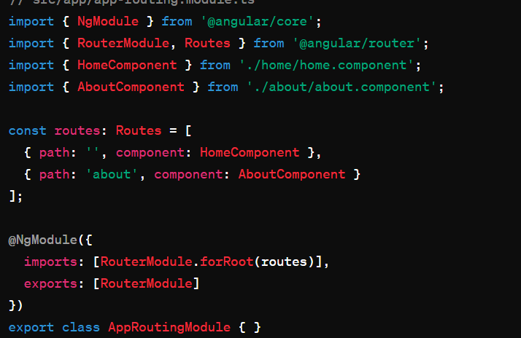

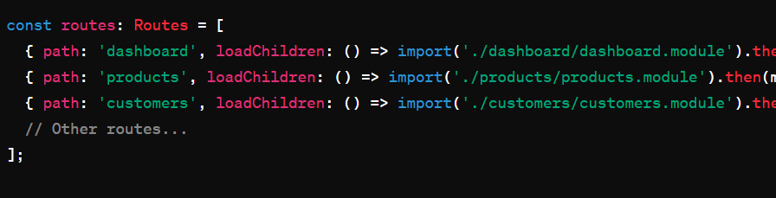

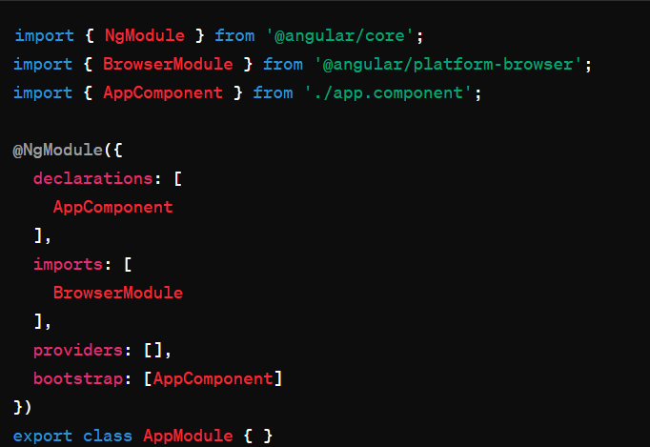
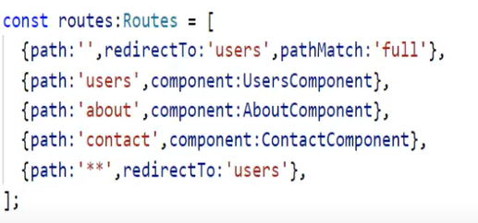
Route parameters
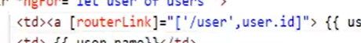


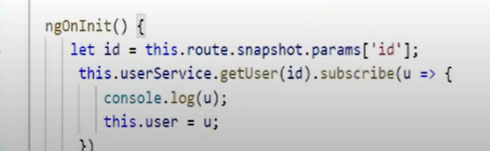
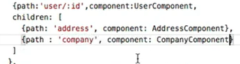
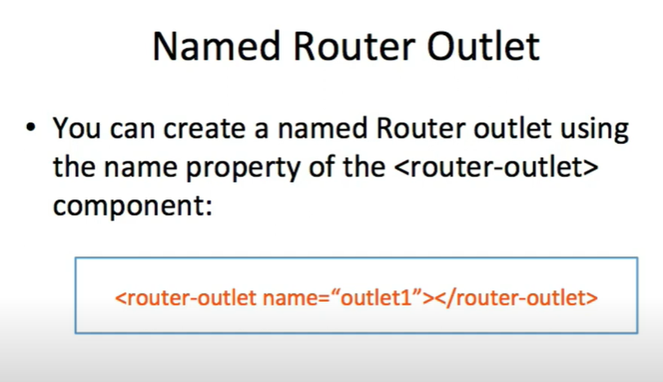
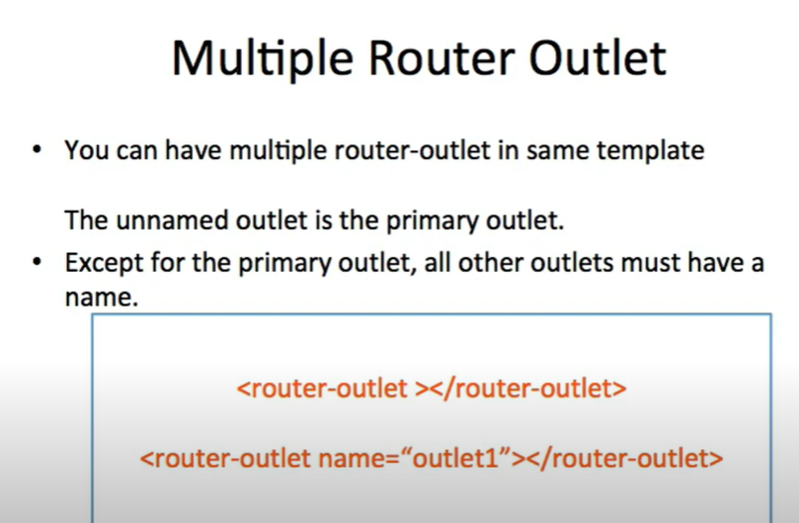
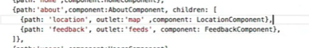
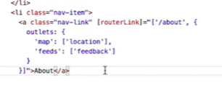

Subject
In Angular, Subject is a type of Observable that allows both subscribing to messages and sending messages to subscribers. It acts as both an Observable and an Observer, making it a powerful tool for implementing communication between components, services, and other parts of an Angular application.
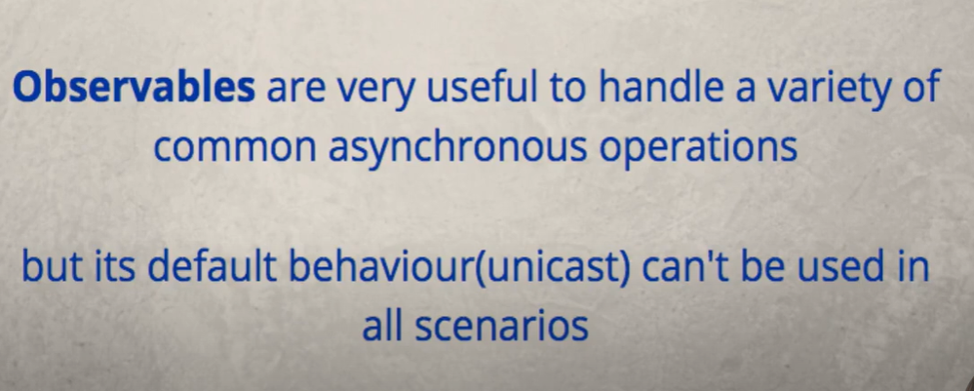


Types

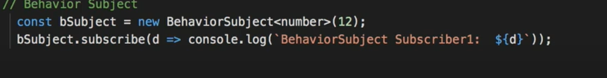
- Behaviour subject notifies all the subscribers with the default value even if next method is not called
- After emitting a new value and new subscribes is declared after it still the subscriber will get the last emitted value , In normal subject it will not happen
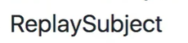
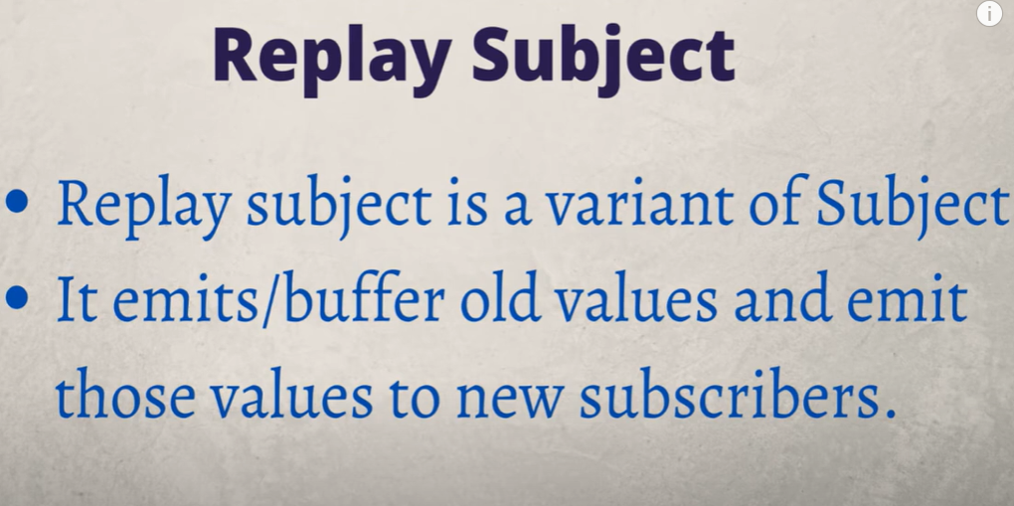
- Replay subject doesn’t have to provide initial value and can buffer old values
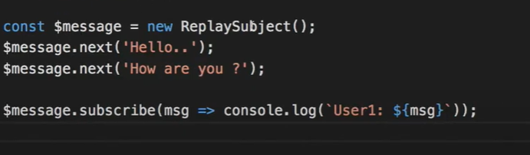
- It consoles all the values
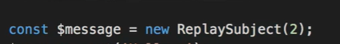
- We can provide buffer size as parameter. Here it gives last 2 values.
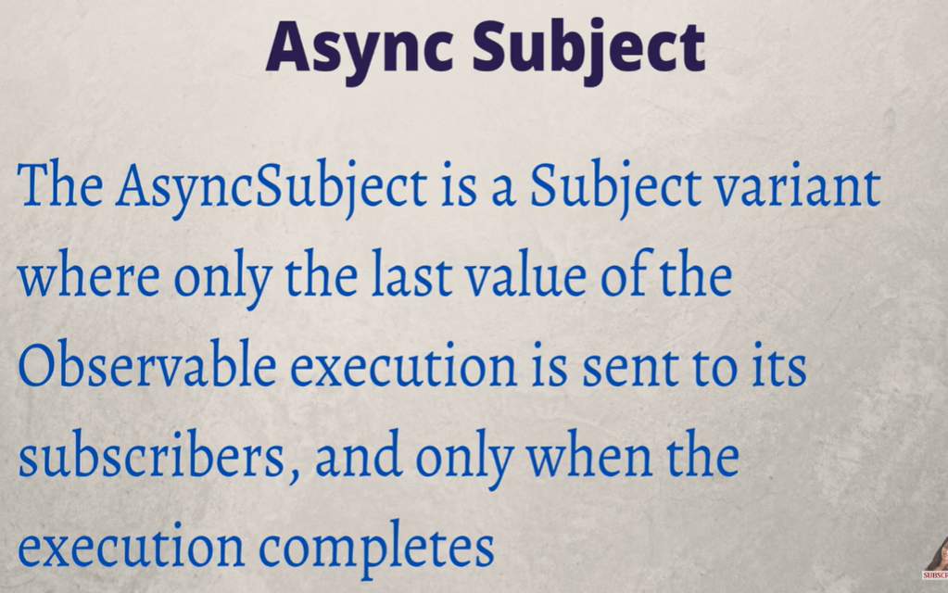

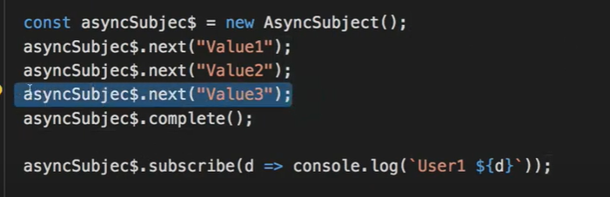
- It consoles the last emitted value
Decorator
In programming, a decorator is a design pattern that allows you to dynamically add behavior or modify the behavior of functions or classes without changing their code directly. In many programming languages, including TypeScript and Python, decorators are implemented as a language feature.
Here are some common uses of decorators in TypeScript and Angular:
- Class decorators:
  - Used to modify the behavior of a class.
  - Often used in Angular for things like dependency injection (@Injectable()), defining Angular components (@Component()), defining Angular modules (@NgModule()), and more.
- Method decorators:
  - Used to modify the behavior of a method within a class.
  - Often used in Angular for things like event handling (@HostListener()), HTTP requests (@Get(), @Post(), etc. in @angular/common/http), and more.
- Property decorators:
  - Used to modify the behavior of a property within a class.
  - Sometimes used in Angular for things like input properties (@Input()) or output properties (@Output()).
- Parameter decorators:
  - Used to modify the behavior of a parameter within a method or constructor.
  - Less commonly used in Angular but can be useful for things like dependency injection (@Inject()).

@Injectable() is a decorator provided by Angular that marks a class as available to be injected with dependencies.
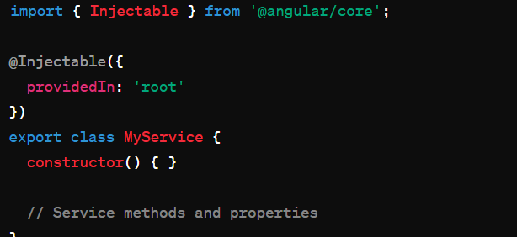
- It's provided in the root injector (providedIn: 'root'). This means Angular creates a single instance of MyService at the root level of the application and injects it wherever it's requested.

Module
- App module imports browser module. Used to configure angular app. Imported only once.
- New modules import common module- ngIf, ngFor
NgModule
The @NgModule decorator in Angular is used to define and configure Angular modules.
The @NgModule decorator is typically used to annotate a TypeScript class, which represents an Angular module. It takes a metadata object as an argument, where you can define various properties and configurations related to the module.
Here's an overview of the properties and configurations that can be specified within the @NgModule decorator:
- declarations:
  - An array of components, directives, and pipes that belong to this module.
  - Components, directives, and pipes listed here are available for use within the module.
- imports:
  - An array of other modules that this module depends on.
  - Modules listed here provide features and functionality that are needed by components and services within the module.
- exports:
  - An array of components, directives, and pipes that should be accessible to other modules.
  - Components, directives, and pipes listed here can be used by other modules that import this module.
- providers:
  - An array of services that are provided at the module level.
  - Services listed here are available for injection throughout the module.
- bootstrap:
  - The root component of the application that Angular should bootstrap when the module is loaded.
  - Typically used in the root module of the application.
- entryComponents:
  - An array of components that are not referenced in any template but are dynamically created (e.g., through ComponentFactoryResolver).
  - Angular's AoT (Ahead-of-Time) compiler needs to know about these components.
- schemas:
  - An array of schema types that allow specifying the schema to be used for error checking in templates.
  - Commonly used schemas include NO_ERRORS_SCHEMA and CUSTOM_ELEMENTS_SCHEMA.
- id:
  - An optional property used to specify a unique identifier for the module.
  - Useful for lazy loading and debugging purposes.

Pipes
In Angular, pipes are a feature that allows you to transform data before displaying it in the template. Pipes are used to format and manipulate data in a template, making it easier to present information to users in a readable and understandable way.

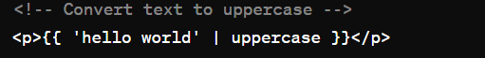
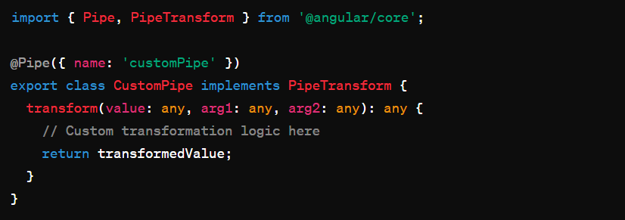
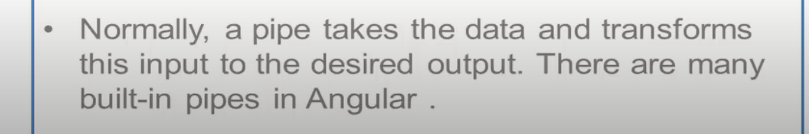
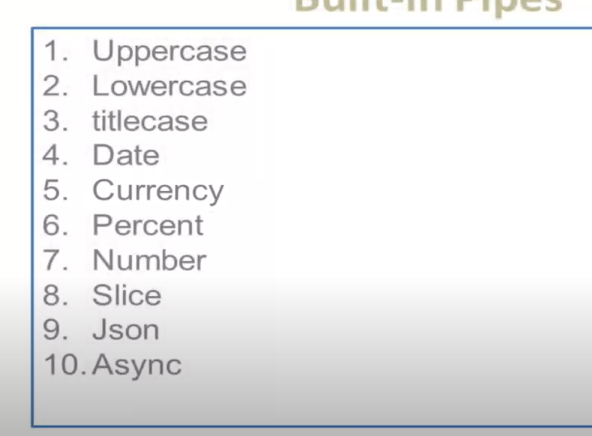
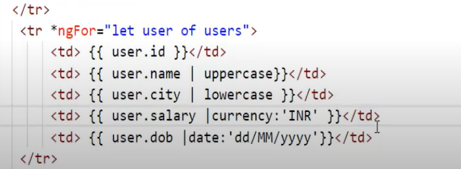

Lifecycle
In Angular, components have a lifecycle managed by Angular itself. This lifecycle consists of a series of lifecycle hooks that you can tap into to perform certain actions at specific points in a component's lifecycle. Understanding these lifecycle hooks is essential for implementing features such as initialization, change detection, cleanup, and more.
Here's an overview of the lifecycle hooks available in Angular components:
- ngOnChanges: Called after one or more input properties of the component change.
- ngOnInit: Called once after the component is initialized and its inputs are bound. It's a good place to perform initialization logic.
- ngDoCheck: Called during every change detection cycle. It's used to implement custom change detection logic.
- ngAfterContentInit: Called once after the component's content has been initialized. It's a good place to perform initialization that relies on the component's content.
- ngAfterContentChecked: Called after the component's content has been checked for changes.
- ngAfterViewInit: Called once after the component's view (and child views) have been initialized. It's a good place to perform initialization that relies on the component's view.
- ngAfterViewChecked: Called after the component's view (and child views) have been checked for changes.
- ngOnDestroy: Called just before the component is destroyed. It's a good place to perform cleanup tasks (e.g., unsubscribing from observables, releasing resources).
Directives
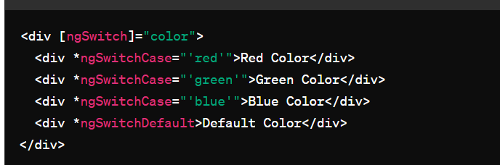

Ahead-of-Time (AOT) compilation is a process used in Angular to convert Angular application code into efficient JavaScript code during the build phase, before the browser downloads and runs the application. This is in contrast to Just-in-Time (JIT) compilation, where the compilation of Angular components and templates occurs in the browser at runtime.

In Angular, the ngModel directive is typically used within a form element to bind input controls (like <input>, <select>, <textarea>) to properties in the component class, enabling two-way data binding between the view and the component.
However, in some cases, you might want to use ngModel without wrapping it in a form element. To enable this behavior, you can use the ngModelOptions directive with the standalone option set to true.

Services
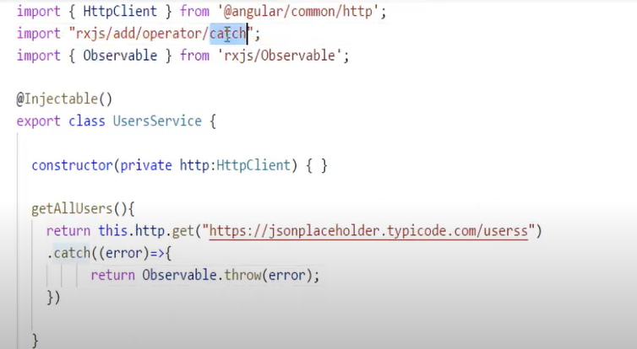

Guards
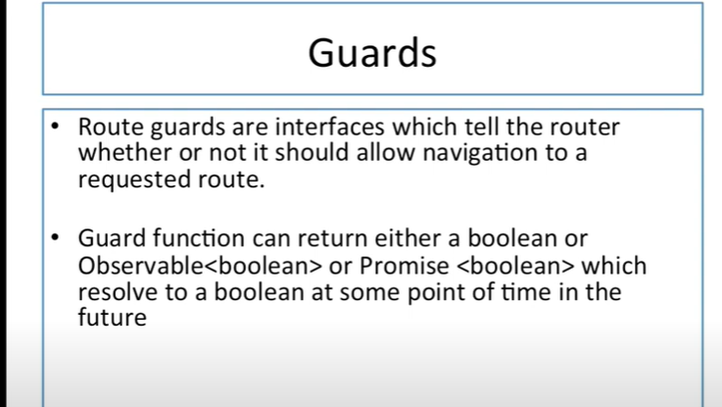
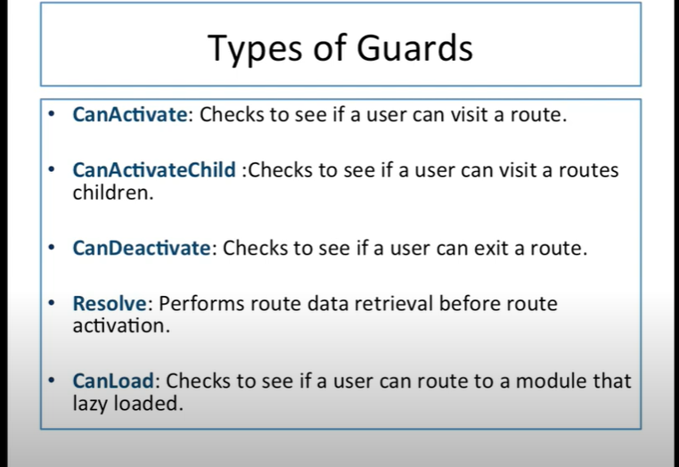

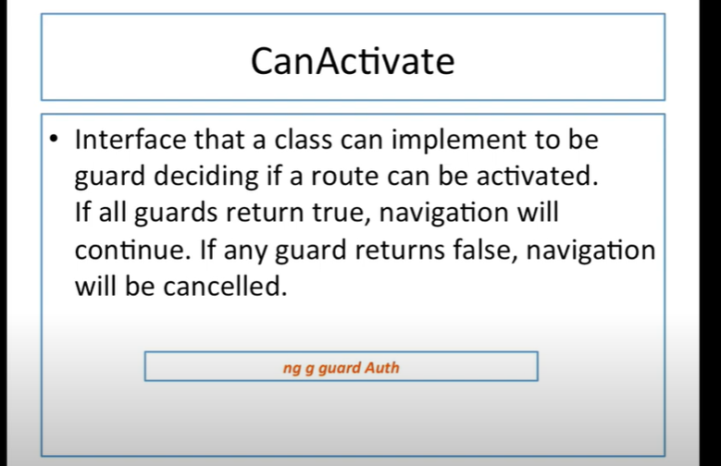
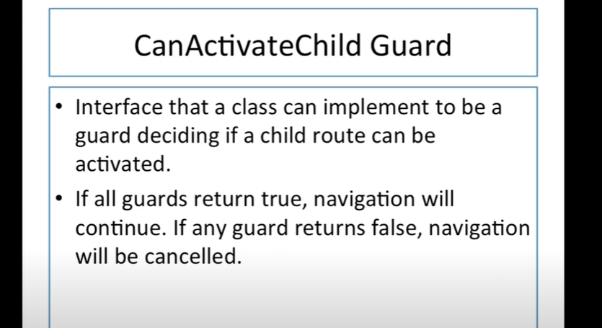
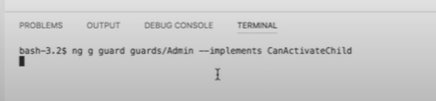
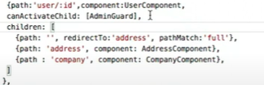
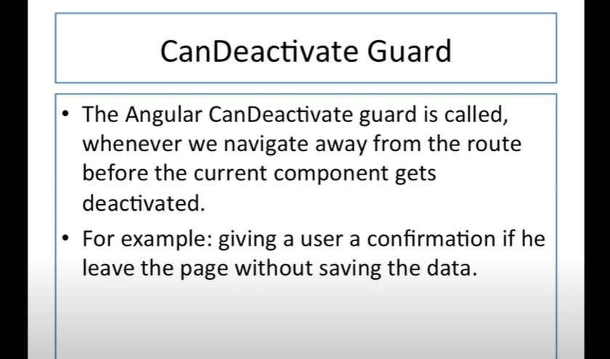
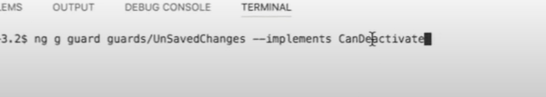
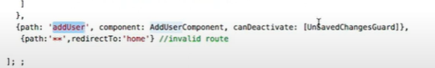
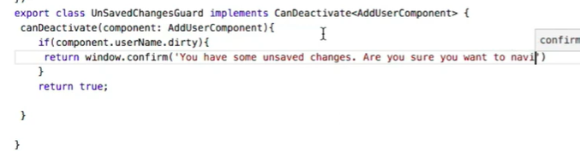

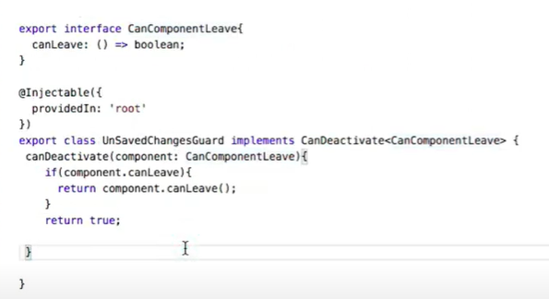
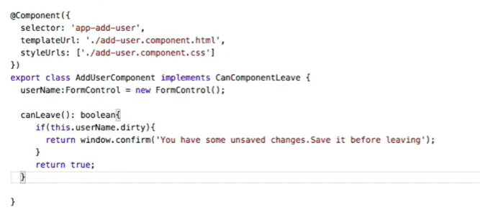

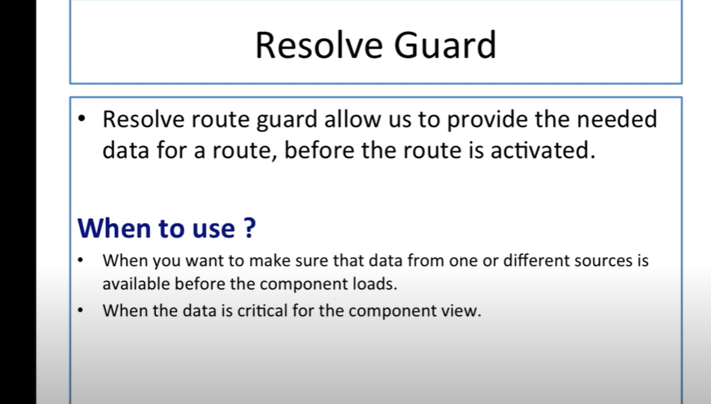
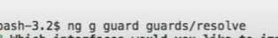
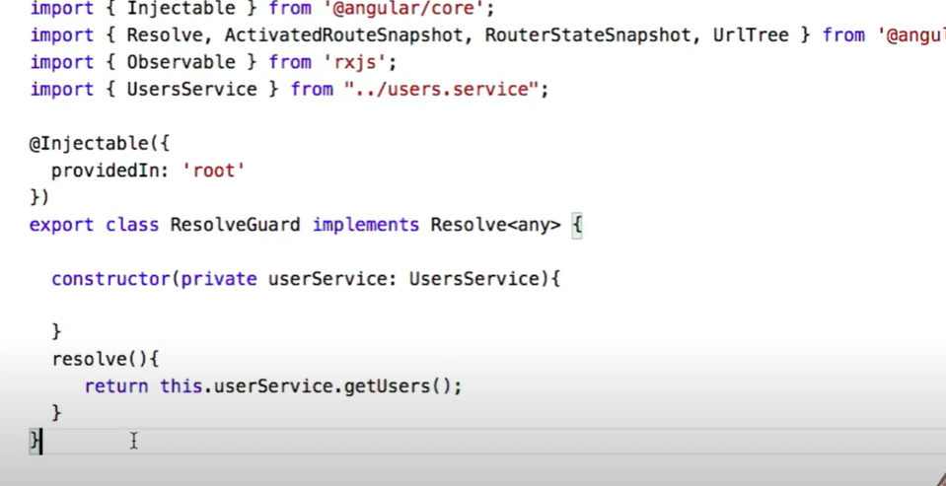
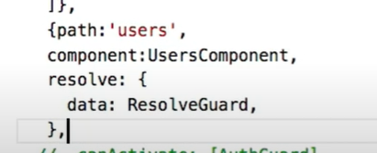
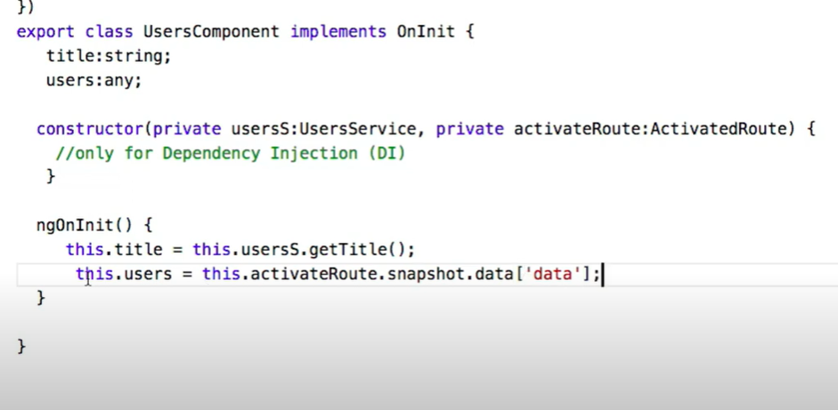

Promises and observables
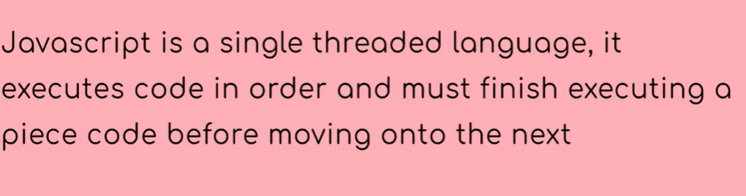

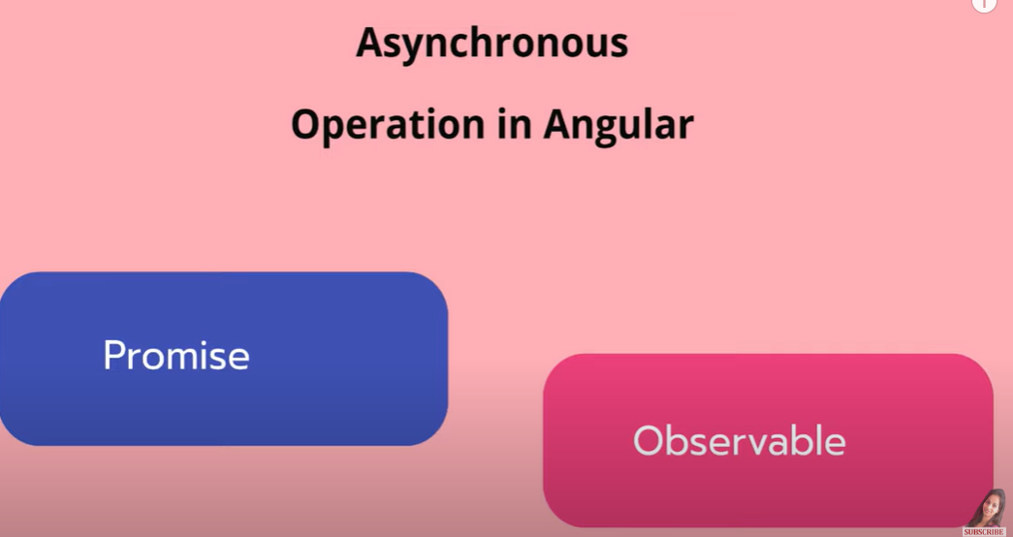
- part of rxjs ( Reactive extension for javascript)
- observable not a angular feature but introduced for handling asunchronous operations.
- Promise and observable are used for handling asynchronous operation
- Promise is native to js whereas we have to import observable from rxjs
( npm i rxjs)
- Promise are eager, ie it call as soon as u define it.
- Observer will be called only if there is a subscriber.
- Promise returns only one value where in observable we can send multiple values
- We can modify the data using observable operator in rxjs eg:filter
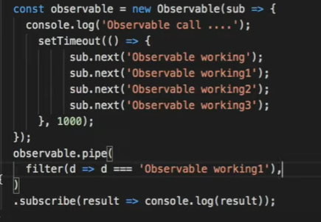
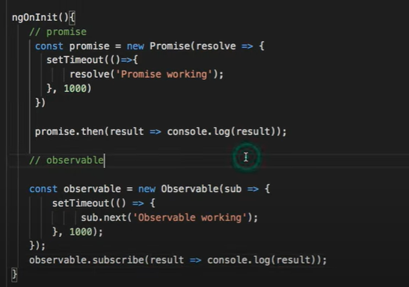

viewChild and viewChildren
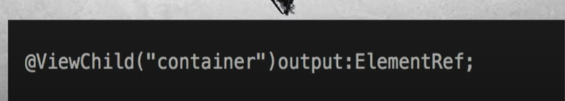

- Same as document.getElementById functionality
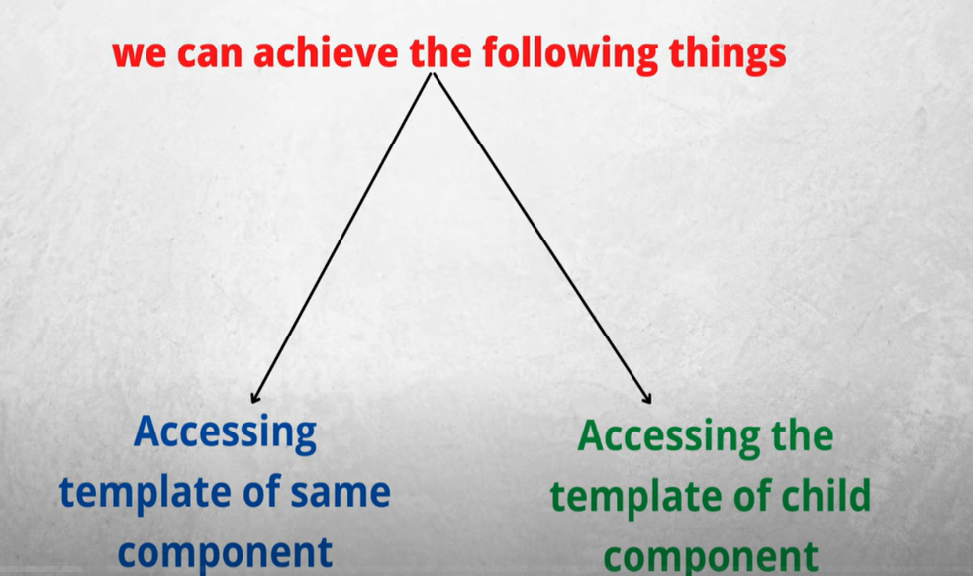
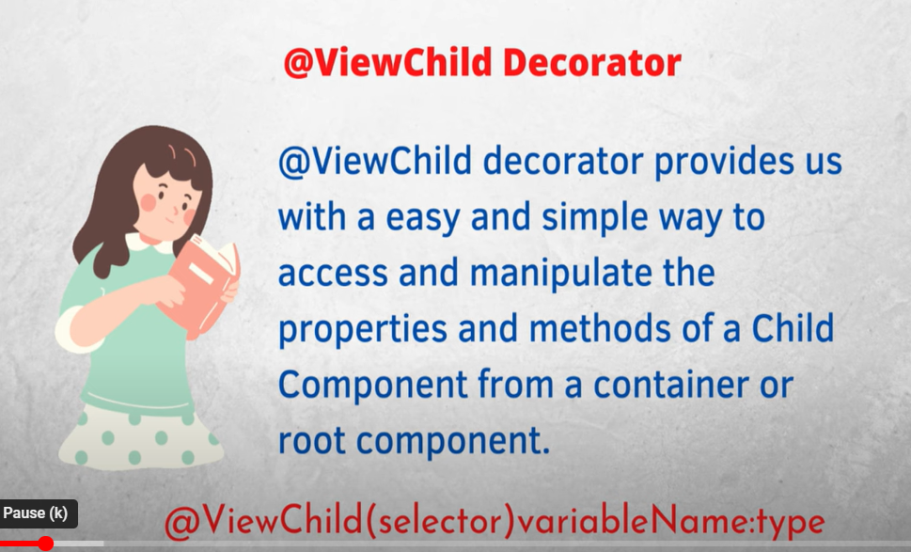
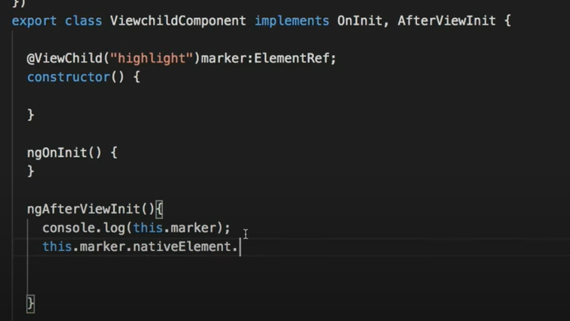
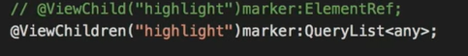
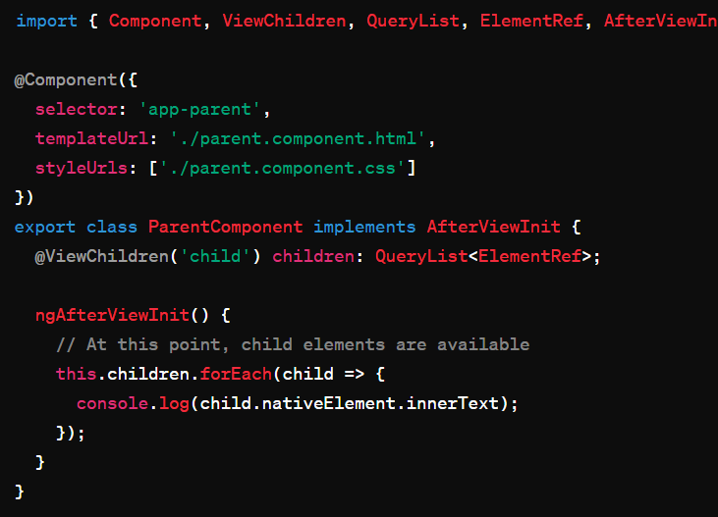
- viewChild only takes first matching element, whereas viewChildren selects all the matching elements
- viewChildern returns array list.

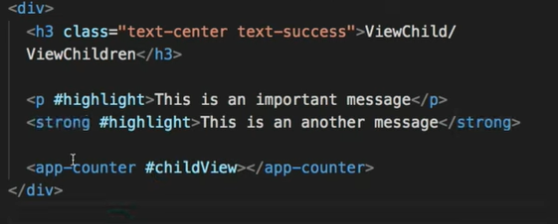
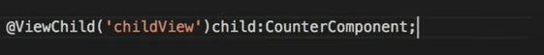
Content Projection
- to pass html content from parent to child
parent
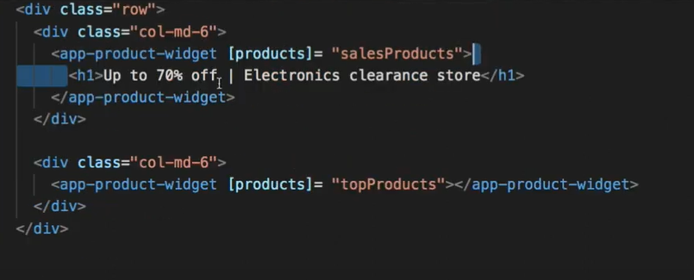
child
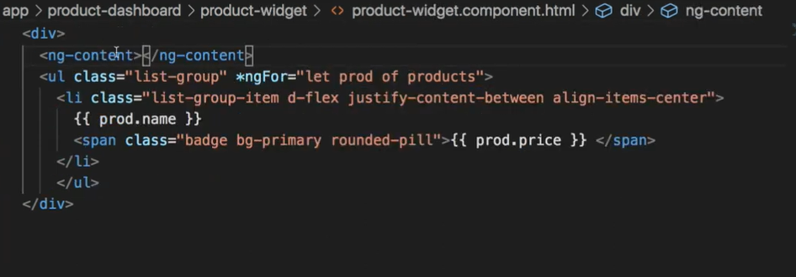

Mutiple content projection
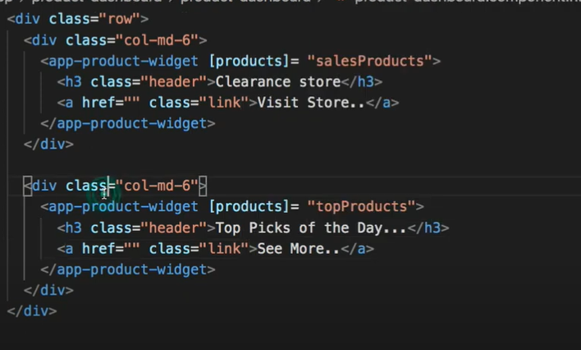
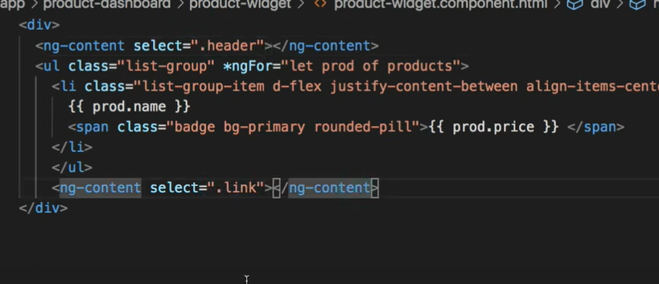
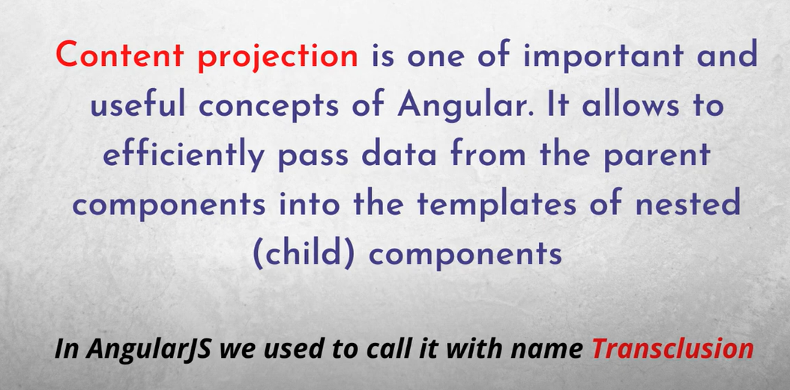

Interceptor

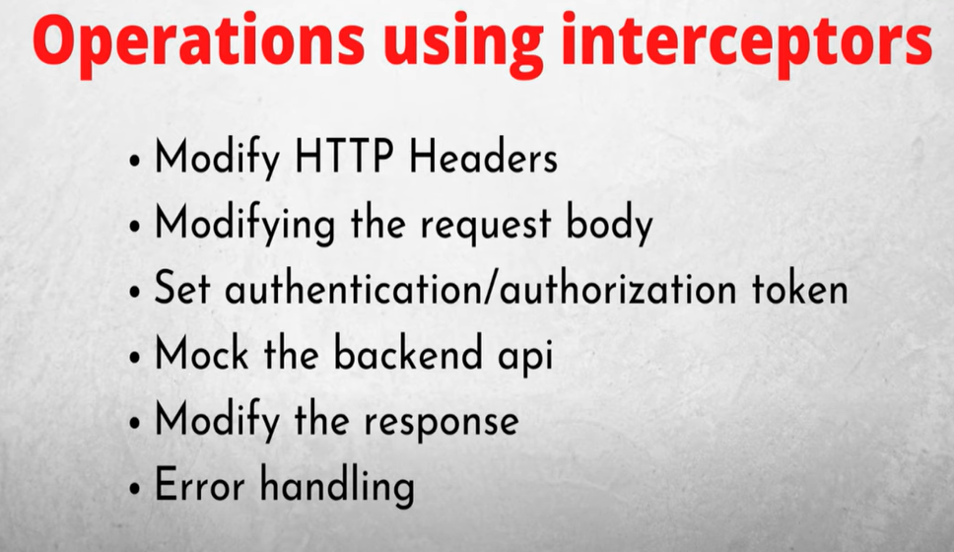
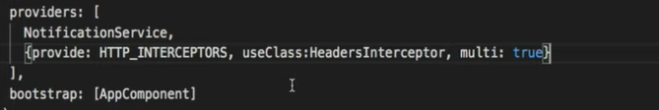
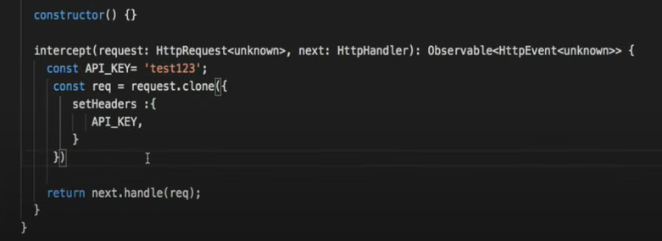

To find response time using interceptor
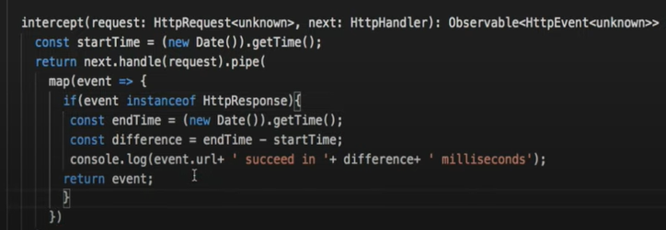

@ContentChild & @ContentChildren

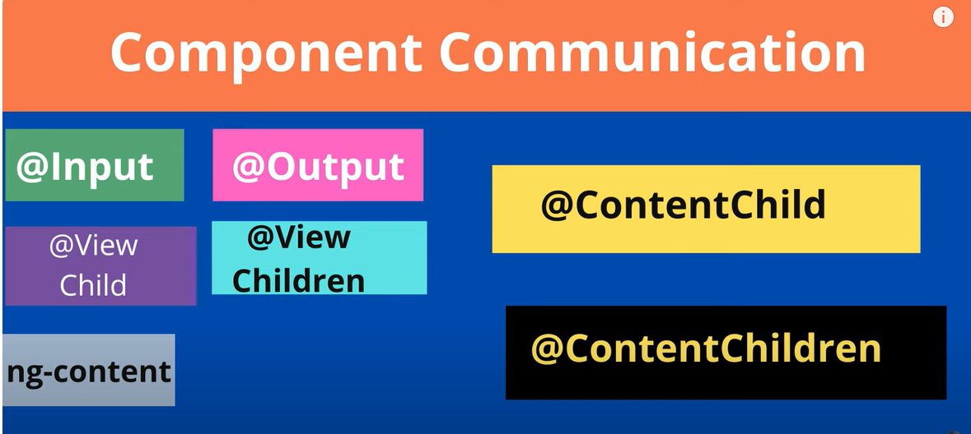

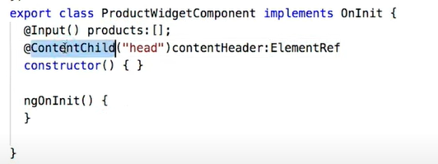

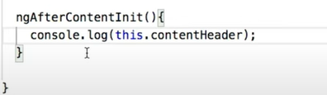

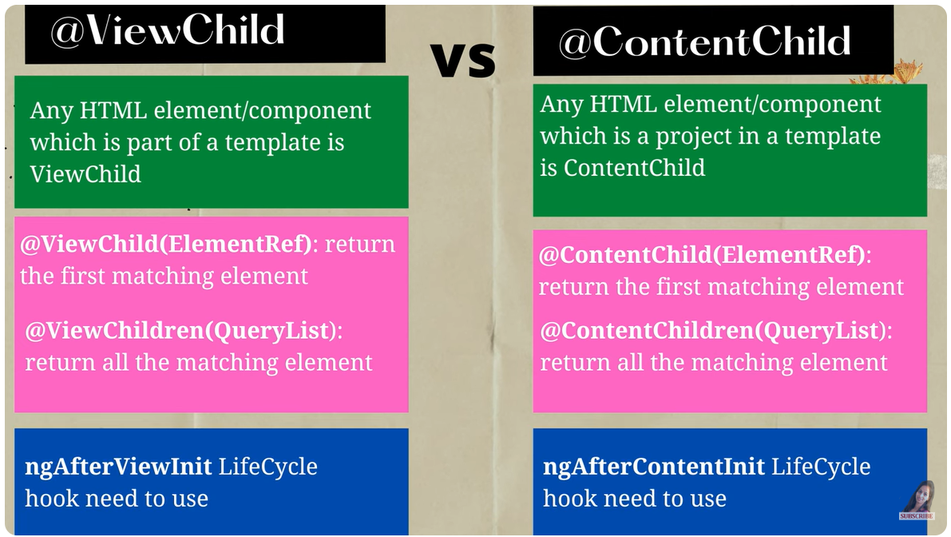

Life Cycle Hooks

